DEBRE BERHAN UNIVERSITY 

COLLEGE OF COMPUTING   
DEPARTMENT OF INFORMATION SYSTEM

project TITLE: **WEB BASED CENSUS MANAGEMENT SYSTEM: ETHIOPIAN POPULATION AND HOUSING CENSUS**

**Group Members ID No**1. Yeshewaget G/sellassie…………………………………1811  
2. Fetene Erkutena…………………………………………1654  
3. Epherme Yirga………………………………………….1729  
4. Meti Feyisa………………………………………………1871  
5. Yonase Marye…………………………………………… 1775

Table of Contents

1. Chapter One 1

Introduction 1

1.1 Background of the project 2

1.2 Statement of the problem 3

1.3 Objective the Project 3

1.3.1 General Objective 3

1.3.2 Specific Objective 3

1.4 Significant of Study 4

1.5 Methodology and tool 4

1.5.1 Data gathering methodology 4

1.5.2 Software requirements: 5

1.5.3 Hardware requirements: 5

1.5.4 Language 5

1.6 Feasibility study of the new system 5

1.6.1 Technical and Operational feasibility 5

1.6.2 Economic Feasibility 6

1.6.3 Political feasibility 6

1.7 Scope of the Project 6

1.8 Beneficiaries of the system 6

1.9 Limitation of the study 7

1.10 Definition of term 7

2 Chapter Two 9

2.1 Introduction of current system 9

2.2 Players in the existing system 9

2.2.1 Enumerator: 9

2.2.2 Supervisor: 9

2.3 Major functions 9

2.4 Business Rule of the system 10

2.5 Report generated 10

2.6 Forms used in the existing system 11

2.7 Problem of the existing system 13

2.8 Practice to be preserved 13

2.9 Proposed solution 14

2.10 Requirements of the Proposed System 14

2.11 Functional requirements 14

2.12 Non- functional requirements 15

3 Chapter Three: System analysis 16

3.1 System models 16

3.2 Scenarios 16

3.3 Use case model 19

3.3.1 Actor 19

3.4 Use case of the proposed system 19

3.5 Object model 28

3.6 Data Dictionary 28

3.7 Analysis level Class Diagram (Conceptual Modelling) 30

3.8 Sequence diagram 30

3.9 Activity diagram 35

3.10 State chart diagram 39

3.11 User interface 39

# Chapter One

## Introduction

Population and housing censuses are the foundation of statistical systems, providing benchmarks of a country's population and housing stock, and baseline information for the production of other statistics.

Population Census the total process of collecting, classifying evaluating, analysing and publishing or distribution of demographic, economic and social data of the population during a certain period of time. Population considers an essential element for production and distribution of material wealth, for planning and implementation of economic, social development or administrative activity or scientific research requires the existence of reliable and detailed data on the size, distribution and composition of population. Population Census forms a most important source, of these basic statistics for comparison.

The increasing complexity of modern life means a greater need to plan housing, schools, roads, transportation, and a vast range of social and economic requirement for nation. This cannot be done without a detailed count of the population. Census is being officially managed by some organizations or government, for example the National Population Commission (NPC). Ethiopia has so far conducted 3 Population and Housing Censuses (PHC) in 1984, 1994, and 2007. The preparations to conduct the 2017 PHC (4th Census) are currently underway, and one of these major undertakings is related to Census data capturing and processing.

The installation of computer in these organizations or bodies that manages census information will assist not only in fast-recording information but also in solving certain problems, which cannot be easily resolved manually. The human resource of any enterprises is considered to be their most valuable assets, if they are properly harnessed and are well motivated to perform their assigned tasks in such a manner as to enhance the enterprises goals and objectives.

Therefore, adequate population records will provide all the necessary information that is associated with people, which include the size of the population, age structure, educational attainment, labour force and socio-economic characteristics, unlike in the manual method which makes access to data and information very tedious. The integration of different databases so that these databases can be merged and processed together and mainly other reasons, prompted the researcher to develop software for this organization, National Population Commission (NPC).

## Background of the project

Census taking in Ethiopia can be traced to have started from as far back as 1989 year. Since then, there have been several attempts to count Ethiopian population. However, these censuses are characterized by some difficulties and deliberate and ill-minded attempts to inflate population figures; just in favour of one geopolitical zone or the other. This does not and cannot represent the nation’s image as regards to human population. As a result of this, the National Population Commission (NPC) was established using the Decree No. 43 of 1989. The brain behind this was to have successful censuses each time and as well accurate demographic data. It is no doubt that this Commission (NPC) was vested with a lot of powers and functions some of which are;

* To undertake the periodic enumeration of the nation’s population through census, sample surveys, etc.
* To establish and maintain the machinery for continuous and universal registration of births and deaths
* To collect, collate and publish data on migration statistics
* To reach and monitor national population polity and set up national population information data bank.

Unfortunately, Ethiopian still relies on foreign statistics population information data bank for most of their population estimation.

## Statement of the problem

There are many problems affecting the National Population Commission from maintaining a steady reliable figures and estimates. These are the more reasons, why the current system have faced problem;

* Inadequate manpower
* Lack of equipment’s
* Poor organisation
* Unstable organization
* Manual bulk carrying of data
* Requires More Resources: Consumes more resources and costs such as paper, pen, transportation cost for paper, and storage place.
* Lack of automated statistical manipulations.
* High Data redundancy and erroneous data storing.
* The current system is not efficient, flexible, reliable, available and difficult to get data.

## Objective the Project

### General Objective

The general objective of this project is to develop web-based online census system for Debre Berhan city.

### Specific Objective

To achieve the above mentioned general objective, the project includes the following specific objective

* To develop computerized software that automatically stores and retrieves all information on human population.
* To create user interface for system users to login in to the system for solving the security problem.
* To develop a reliable system that could be used in collecting data/information on human population.
* To develop a system that will support direct access to the specific and required information
* To Reduce the time taken by management in coming up with concrete decisions
* To deal with data redundancy within the database
* To Help in efficient collection, storing, updating , processing and analysis of data for ease in manipulation

## Significant of Study

* The system will solve problem associated with the acquisition, storage, and retrieval of information on human population with ease.
* A timely retrieval of information is anticipated with efficiency and reliability.
* It will provide security to data that are unauthorized, users will not gain access to those files and fraud will be minimized in the society which will lead to improvement in administration processes.

## Methodology and tool

### Data gathering methodology

The following data gathering methodology are to develop the proposed system;

* **Interviewing** **-** We interview the Coordinator. This will enable us to know the requirements and if any training will be required before the system is implemented.
* **Observation –** we have observed about Ethiopian population and house census in order to gain basic informationThis help us to see the problems the enumerator, supervisors are facing. This can be done by attending one census process. In the existing system there is different problem in terms of time and economically, so our system answer this problem,
* **Questionnaires**:-It contains fixed-response questions about various features of an organization. This also another data gathering methods that are used for collecting information from the stake holder. This can be in terms of written paper we have distributed for individuals for north shawa population and housing census branch.

### Software requirements:

* Windows 7 or higher
* Visual Studio 2010
* Microsoft Office 2010.
* Online moqup

### Hardware requirements:

* Processor – i3
* Hard Disk – 5 GB
* Memory – 1GB RAM
* Desk top computer
* Printer to print our documentation.
* 16 GB flash drive used to make backup of important information in case of any damage.
* 3 optical disks - used to make backup of important information in case of any damage.

### Language

* PHP (We use PHP language for the system development; to create user interface and our system (software) will be compatible on all hardware).
* MySQL

## Feasibility study of the new system

The feasibility study is the preliminary study that determines whether a proposed system project is financial, technically and operationally viable. The alternative analysis usually include as part of the feasibility study, identifies viable alternatives for the system design and development.

### Technical and Operational feasibility

Our project is technically feasibly b/c it is fast and easily to use but in manual system it is difficult since it is manual

* Our proposed system is time and resource saver in census process it have no need more resource as existing system
* Assessing the size of the manpower, questionnaires and other equipment required for the census is simple
* Easily Provide comparable workloads to the enumerators
* Ensure that the census is completed in the specified time
* Operationally our system is not complex but in manual Data capturing for the 1984 and 1994 Censuses was carried out using the traditional keyboard-based data entry method.
* Our proposed system is digital so it reduce human power the supervisor assign people for each zone, worda, kebele .
* Our project have a user friendly interface that can be implemented easily and can perform many tasks that can be used by users.

### Economic Feasibility

In the existing system, many people are involved in the process but in the proposed system, number of persons involved be reduced drastically.

After this project finished it will reduce the cost of paper, pen, and transportation will be avoided or we automate the system from manual system so that our project is economically feasible.

### Political feasibility

Our project will not conflict with the rule and regulation of Ethiopian constitution and Ethiopian statistical agency rather it gives advantage to our country.

## Scope of the Project

The major aim of the project is to design a system that will have all information about human population and retrieving of data whenever needed in the society. It focuses on the registration, retrieval and management of information about individuals in the society.

## Beneficiaries of the system

The beneficiary of this system includes:

* Administrator: - unlike the existing system the proposed system enable the admin to manage the system Policy maker: - can access or get organized data easily for policy making.
* Supervisor:-benefit from the system by easily supervising the enumerator online by using browser.
* Journalists and researcher can access or get organized data easily from the system
* Government ministries and    Local authorities: - They will get error free census data to provide infrastructure for the people.
* Private and public companies:- They can access or get organized data for different purpose

## Limitation of the study

During the course of this study, many things militated against its completion, some of which are;

* Lack of finance
* Refusal of the National Population Commission Awka, to give detailed answers and in some cases, no answer at all to some questions.
* This project is limited to all the data associated with census population figure gotten from the National Population Commission.
* Due to time factor, not all the commissions were reached for source of data and information.
* The employee that has not basic skills and knowledge of computer cannot accesses proposed system.

## Definition of term

**DEMOGRAPHY:** Demography is the scientific study of the changing number of births, deaths, diseases, etc in a community over a period of time.

**POPULATION:** Population is the total number of people living in a particular area, city or country.

**CENSUS:** A census is the procedure of systematically acquiring and recording information about the members of a given population.

**ENUMERATION:** Enumeration is the head to head count of all individuals in a given society within a period of time.

**MIGRATION:** Migration is the act of moving from one region or country to another. It is the movement of a group of people, births, or other animals that move in group from one region to another.

**ESTIMATION:** Estimation is the act of making an approximate calculation of something.

**PROJECTION:** Projection is an estimate of the rate or amount something.

# Chapter Two

## Introduction of current system

When analysing an existing system, note is taken on how the existing system works or the procedures on how jobs and activities are been carried out in the organization. During system analysis, investigation of an existing system in order to understand its operation is carried out for better understanding of the existing system and the introduction of more efficient and economic means of achieving the desired goals is also made.

The analysis of the present system was carried out to identify the existing problems affecting the system; this would enable the analyst to validate or invalidate the present system if many weaknesses were found. The analyst would go ahead in designing the system that would replace the existing system that must have been proved unsatisfactory.

## Census and Surveys Department

The Departments objective is built around the decennial National Population and Housing Censuses and other socio-demographic surveys while key activities include census and survey questionnaire design, data collection, analysis and dissemination. The Census Department basic function is to ensure strategic planning and execution of National Population and Housing Censuses, and institutional surveys in collaboration with other department, or Unit established for the purpose. In this regard the department implements the Commission's constitutional mandate of undertaking the National Population economic and social censuses and surveys.

The census department is made up of 4 divisions as follows

* Census division
* Survey division
* Evaluation and analysis division
* Dissemination and publication division

## Players in the existing system

### Enumerator:

The Enumerator is the one who has a privilege to collect and fill the census by collecting the information of the people manually. Each enumerator is given the map of an enumeration area along with other census document and he/she is responsible to record all person and Households in that enumeration area without omission and duplication. Each enumerator has a national enumerator number given by Debre Berhan city statics agency to identify each and every enumerator. The enumerator validates the collected census by its name and signature.

### Supervisor:

The supervisor oversees the affairs of the enumerators and supply materials (if needed) to them and visits the supervisory areas before the commencement of the census. Also, he intimates the chiefs about the exercise and solicits their supports during the exercise. The supervisor in turn reports to the controller for urgent attention as the case may be. The controller heads the state office of the National Population Commission and oversees the enumeration exercise in the state, and after the exercise report directly to the commissioner.

## Major functions

**Data Input:** Data has been inputted directly by the enumerator.

**Data Processing:** Count the inputted information collected by the enumerator manually.

**Data Output:** The data collected so far is recorded in a document and the document delivered to the Debre Berhan city statistics agency.

## Business Rule of the system

A business rule is an operating principle or policy the software must satisfy. It often pertain to access control issues, business calculations, or operating polices and principles of the system. Therefore, our new system has the following business rules:

BR1: Enumeration area should be mapped and unique code is given for each area.

BR2: A person to be counted as a member of a given family he/she must live there at least for 6 months.

BR3: A newly married person is counted with his/her new family regardless of the time she/he started to live with her/his new family.

BR4: For one woreda 6 enumerators and one supervisor should be assigned.

BR5:200 families are given to one enumerator for urban areas.

BR6: The enumerator is given up to 150 families for rural areas.

BR7: The enumerators should be well trained.

## Report generated

In the existing system, report was generated by a manual system from the collected information.

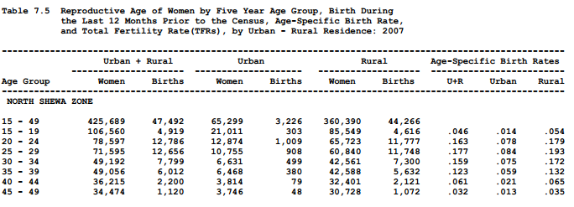

## Forms used in the existing system

This form sections are used to collect data from the population

Area identification

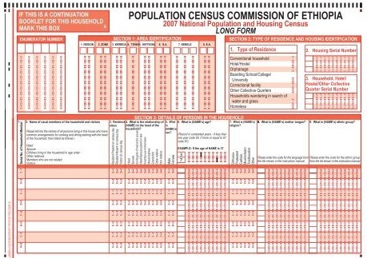

**Type of residence and housing identification**

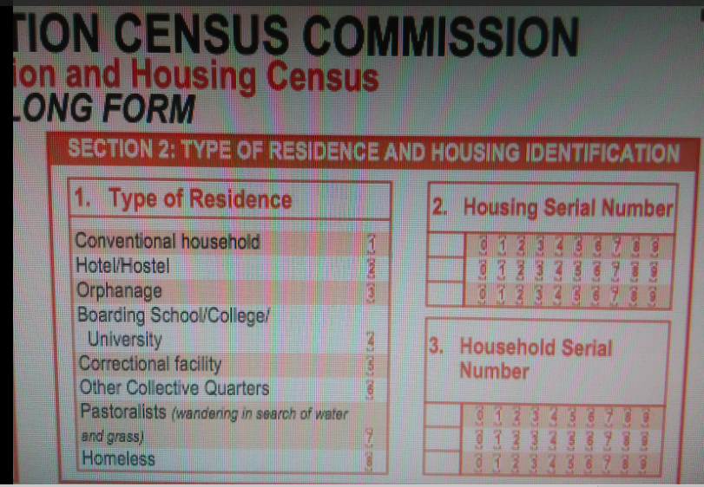

## Problem of the existing system

**Performance:**

In the existing manual system there are more paper work, and didn’t respond very fast.

***Input:*** In the existing system data was collected door to door by the enumerator.

***Security:*** In the existing system there is no data security mechanism to protect the collected data.

***Efficiency:*** Since the existing system is manual it didn’t provide efficient data.

## Practice to be preserved

* Mapping of census area to identify the specific area to enumerator.
* Giving code for the enumeration area.

## Proposed solution

We are going to improve the drawbacks of the existing system by developing an automated, user friendly and interactive graphical user interface system which will:-

* reduce complexity of existing system,
* manage time effectively,
* make work easy,
* make the data error free
* utilize available resource effectively,
* Enhance the efficiency and diversification of services activities

## Requirements of the Proposed System

* Here we have two requirements.

## Functional requirements

The main functional requirements of this system are:

* Add Officers
* Manage Officers
* View Reports + Search Sort Function.
* Login
* View new Request.
* View Corrected Request.
* Validated Members
* Reject Member / Ask for details.
* Add Family Member (with details like name, dob, sex, email, phone, Education, Occupation, Address, Area, City, State) specify if any other,
* Upload Adhaar Card / birth certificate / Document for each Member
* View correction request.
* View Request status.
* The system shall record information of persons and housing unit.
* The system shall display the characteristics of individuals.
* The system must calculate the total number of population.

## Non- functional requirements

The non-functional requirement of the system deals with how well the system provides service to the user.

**Performance:**

***Easy to use*:** unlike manual the automated system is easy to use.

***Fast and reliable:***The time needed to access the data is much less than the existing system.

***Maintainability*:** To ensure that the system continues to work properly by checking it regularly and making repairs and adjustments if required.

* ***Scalability:*** The system should provide flexibility and production of new versions suited for new environments and changing needs.
* ***Usability*:** The system should be easy to use by all.
* ***Availability***: The system should be up and running whenever needed.
* ***Security and access permission****:* the system should provide controlled access to information while on transmission, only authorized users should access and modify data.
* ***Supportability:*** since our project is done by php, the code can run in any browsers.
* ***Legal:*** our group uses paid version of software’s to develop the system.
* ***Interface:*** our group designs the user interface by php and css to make the interface more attractive.

# Chapter Three: System analysis

System design can be regarded as the drawing, planning, sketching or arranging of many separate elements into viable unified whole. While the system analysis phase is concerned with the question of what the system is doing and what it should be doing to meet user’s requirements, the system design phase centres on how the system is developed to meet the requirements.

The goal of the chapter is to prepare the designer of the project needs and requirements before the actual system is implemented. The system is first evaluated to verify how it operates, and then proposed system is designed of its specifications with technological options. It is a description of the structure of the software to be implemented, the data which is part of the system, the interface between system component and the algorithms used. The objective of this document is to detail the operation of the information system. The design document will hence help in the final design of the system. Graphical representation will be used to create a clear understanding and expected graphical user interface.

## System models

System modelling involves the evaluation of system components in relationship with one another to determine their requirements and how to satisfy them. Some system modelling tools will be employed during the course of this project that will support development tasks, from analysis to design, then to implementation. This will be represented with the use of the sequence diagram, activity diagram, state chart diagram, collaboration diagram and class diagram for the online censu

## Use case model of the proposed system

**Use case diagrams** are usually referred to as behaviour diagrams used to describe a set of functions that some system or systems should perform in collaboration with one or more **external users** of the system. .

Each use case should provide some observable and valuable result to the actors or other stakeholders of the system.

The proposed system use case includes the following:

* Login
* Configure admin settings
* View census report
* Fill census form
* Manage census data
* Search
* Add enumerator
* Generate report

### Actor

In this system, the interaction of actors with the system is through the interface of the system. In the proposed system, the following actors are identified.

* Administrator
* Supervisor
* Enumerator and
* End-user



## Scenarios of the use case

Use case scenario for login

|  |  |
| --- | --- |
| Use case name | Login |
| Use case ID | UC-1 |
| Participating Actors | administrator, enumerator, supervisor, end user |
| Precondition | User must have user name and password. |
| Basic course of action | action  Step:   1. User click login button 2. The user inputs user name, password and id number |
| Post condition | The actor is now log in into the system |
| Exit condition | The actor logout from the system |

Use case scenario for configure admin setting

|  |  |  |
| --- | --- | --- |
| Use case name | Configure admin settings | |
| Use case ID | UC-2 | |
| Participating Actors | Administrator | |
| Precondition | Administrator must have to login. | |
| Basic course of action | Action  Step:   1. Administrator login to the system 2. Administrator select configure option button/menu from admin page 3. Administrator selects the setting options one by one and changes the setting. 4. Administrator click on save settings button | |
| Post condition | Administrator is now configured the system. |
| Exit condition | Admin logout from the system |

Use case scenario for view census report

|  |  |
| --- | --- |
| Use case name | *view census report* |
| Use case ID | UC-3 |
| Participating Actor | End –user |
| Precondition | User must have to go home page |
| Basic course of action | Action  Step:   1. The end-user go to census home page 2. the end-user click census report option from menu 3. the user select different census report 4. the user can see the census report |
| Post condition | The user have seen view census report |
| Exit condition | The user view give census report |

Use case scenario for fill census form

|  |  |
| --- | --- |
| Use case name | fill census form |
| Use case ID | UC-4 |
| Participating Actors | Enumerator |
| Precondition | The enumerator first login and click fill form button |
| Basic course of action | Action  Step:   1. User login to the system as enumerator 2. Enumerator select fill census form option from enumerator page 3. The enumerator fills that form 4. enumerator clicks one fill census form button |
| Post condition | The actor fill census form |
| Exit condition | The actor is now populate the census |

Use case scenario for Search

|  |  |
| --- | --- |
| Use case name | Search |
| Use case ID | UC-6 |
| Participating Actors | Administrator |
| Precondition | Administrator must login as administrator |
| Basic course of action | Action  Step:   1. Administrator login to the system 2. Administrator click search button from admin page 3. Administrator inserts the keyword |
| Post condition | The Administrator is now search the census |
| Exit condition | Admin logout from the system |

Use case scenario for Register new user

|  |  |
| --- | --- |
| Use case name | Register new user |
| Use case ID | UC-8 |
| Participating Actors | Supervisor |
| Precondition | Supervisor must login to system |
| Basic course of action | Action  Step:   1. The Supervisor login to the system 2. The Supervisor click add user button 3. Supervisor type information about the user |
| Post condition | The supervisor create new user |
| Exit condition | The supervisor logout from the system |

Use case scenario for Generate report

|  |  |
| --- | --- |
| Use case name | Generate report |
| Use case ID | UC-9 |
| Participating Actors | Supervisor |
| Precondition | supervisor must login to the system |
| Basic course of action | Action  Step :   1. Supervisor login to the system 2. Supervisor click generate report button. |
| Post condition | The supervisor generate report |
| Exit condition | The supervisor logout from the system |

Use case scenario forManage census data

|  |  |
| --- | --- |
| Use case name | Manage *census data* |
| Use case ID | UC-10 |
| Participating Actors | Administrator, Enumerator |
| Precondition | Actor must login to the system. |
| Basic course of action | Action  Step:   1. Enumerator login to the system 2. Enumerator click manage button 3. Enumerator update, display or delete enumerated |
| Post condition | The Enumerator is now managed the enumerated data |
| Exit condition | The Enumerator logout from the system |

Use Case Description for login

|  |  |
| --- | --- |
| Use case name | Login |
| Use case ID | UC-1 |
| Participating Actors | administrator, enumerator, supervisor, end user |
| Description | The authentication for authorized users in the system and deliver them the right to visit their specified page |
| Precondition | user must have user name and password |
| Basic course of action | action  Step:   1. User initiate login system 2. System display login form 3. The user inputs user name, password and id number 4. The system checks the validity of the entry and then verifies whether the user is authenticated and authorized. 5. The system displays the requested page for further action. |
| Alternate flow of Action | 1A. If the user’s entry (user name, ID number and Password) is not correct the system displays error message and return to step 2. |
| Post condition | The actor now use the system. |
| Exit condition | The actor logout from the system |

Use Case Description for configure administrator setting s

|  |  |
| --- | --- |
| Use case name | Configure admin settings |
| Use case ID | UC-2 |
| Participating Actors | Administrator |
| Description | How administrator configure and manage the sitting of the system |
| Precondition | Administrator must have to login. |
| Basic course of action | Action  Step:   1. User login as admin to the system 2. The System display admin page 3. Administrator select configure option button/menu from admin page 4. The configuration setting options are displayed by the system 5. Administrator selects the setting options one by and changes the setting. 6. Administrator click on save settings button 7. The system display done message |
| Post condition | Administrator is now configured the system |
| Exit condition | The administrator logout from the system |

Use Case Description for view census report

|  |  |
| --- | --- |
| Use case name | view census report |
| Use case ID | UC-3 |
| Participating Actors | End –user |
| Description | How an end-user view census report |
| Precondition | User must have to go home page |
| Basic course of action | Action  Step:   1. The end-user go to census home page 2. the end-user view census report option from menu 3. system display view census report page 4. the user select different census report 5. system display the census report 6. the user can see the census report |
| Post condition | The user have seen report about census |
| Exit condition | The user leave the system |

Use Case Description for fill census form

|  |  |
| --- | --- |
| Use case name | fill census form |
| Use case ID | UC-4 |
| Participating Actors | Enumerator |
| Description | How a system user enumerate the population |
| Precondition | Enumerator must have to login with user name and password |
| Basic course of action | Action  Step:   1. User login to the system as enumerator 2. System display enumerator page 3. Enumerator select fill census form option from enumerator page 4. System display the fill census form 5. The enumerator fills that form 6. System validate the filled information 7. The system populate the census 8. System display populated message |
| Alternate flow of Action | 7.If the filled information is not correct   1. System displays error message And continues from step 4 |
| Post condition | The enumerator is now populated the census |
| Exit condition | The enumerator logout from the system |

Use Case Documentation for give feedback

|  |  |
| --- | --- |
| Use case name | Give feedback |
| Use case ID | UC-5 |
| Participating Actors | End –user |
| Precondition | User must have email address |
| Description | How an end-user give feedback |
| Basic course of action | Action  Step:   1. The end-user go to census home page 2. The user select feedback or contact us option from home page 3. system display feedback page 4. the user inserts name, email address and give feedback on the text area provided 5. user click on feedback button 6. system saves the feedback and display each feedback on admin page 7. system display the success message |
| Post condition | The user gives feedback |

Use case description for Generate report

|  |  |
| --- | --- |
| Use case name | Generate report |
| Use case ID | UC-6 |
| Participating Actors | Supervisor |
| Description | How the supervisor generates the report |
| Precondition | supervisor must login to system |
| Basic course of action | Action  Step:   1. Supervisor initiate login 2. The system display login form 3. Supervisor enters user name and password. 4. The system display menus. 5. Supervisor click generate report button and report criteria. 6. The system generates report based on the criteria. |
| Post condition | The supervisor generate report |
| Exit condition | The supervisor logout from the system |

Use Case Documentation for Search

|  |  |
| --- | --- |
| Use case name | Search |
| Use case ID | UC-7 |
| Participating Actors | Administrator |
| Precondition | administrator must have to login |
| Description | How administrator search the required information. |
| Basic course of action | Action  Step:   1. User login as administrator to the system 2. System display Administrator page 3. User select Search user option from user page 4. The system display the field to be searched 5. User select the field 6. Administrator click on search button 7. System search the required information 8. System display done message |
| Post condition | The required information is now searched |

|  |  |
| --- | --- |
| Use case name | Register |
| Use case ID | UC-8 |
| Participating Actors | Supervisor |
| Precondition | User must have to login |
| Description | How supervisor register each enumerator in its supervision area |
| Basic course of action | Action  Step:   1. The user login as supervisor 2. System displays supervisor page 3. The user select register user option from supervisor page 4. system display the form 5. the supervisor fill the form 6. user click on register button 7. system register each user 8. system display the success message |
| Post condition | The user is now registered |
| Exit condition | The supervisor logout from the systems |

|  |  |
| --- | --- |
| Use case name | manage census data |
| Use case ID | UC-9 |
| Participating Actors | Administrator, Enumerator |
| Description | How a system user enumerate the population |
| Precondition | Enumerator must have to login with user name and password |
| Basic course of action | Action  Step:  1.Actor login to the system as enumerator  2. System initiates sub activity update (enumerated, census), delete (enumerator, enumerated, supervisor), display enumerated.  2.System display enumerator page  3.Actor select populate census form option from enumerator page  4.System display the fill census form  5.Actor fills that form  6.System validate the filled information  7.The system populate the census  8.System display populated message |
| Alternate flow of Action | 7A1. If the filled information is not valid   1. System displays error message   The use case continues from step 4 |
| Post condition | The enumerator is now populated the census |
| Exit condition | The enumerator logout from the system |

Use case description for registe**r** Use case description for manage census data

|  |  |
| --- | --- |
| Use case name | update enumerated |
| Use case ID | S1 |
| Participating Actors | Administrator, Enumerator |
| Precondition | User must have to login |
| Description | How a system user update the census |
| Basic course of action | Action  Step:   1. User login into the system as enumerator 2. System display enumerator page 3. enumerator select update census option from enumerator page 4. System displays update census page 5. Enumerator enter information related to the record to be updated 6. System displays the census record to be updated 7. Enumerator updates the census field 8. System validate information 9. System updates the census record 10. System display update message |
| Post condition | The enumerator is now updated the census |

Use Case Documentation for update enumerated (s1)

Use Case Documentation for delete census (S2)

|  |  |
| --- | --- |
| Use case name | Delete census data |
| Use case ID | S2 |
| Participating Actors | Administrator, Supervisor, Enumerator |
| Precondition | user must have to login |
| Description | How a system user Delete census |
| Basic course of action | Action  Step:   1. Actor login to the system 2. System display the admin page 3. Actor select the delete census option from admin page 4. System ask the user to insert keyword 5. Actor inserts the keyword 6. Actor click on delete button 7. System check for the existence of specified keyword 8. System display conformation for deletion 9. Actor confirm the deletion 10. System display done message |
| Alternate flow of Action | 7A1. if the requested keyword is not found in the database   1. The System display not found message 2. Use case continue from step5   9A1. if the user does not needs to delete the information   1. User click on cancel button |
| Post condition | The Administrator is now Deleted the census |

|  |  |
| --- | --- |
| Use case name | display enumerated |
| Use case ID | S3 |
| Participating Actors | Supervisor , enumerator |
| Precondition | user must have to login |
| Description | How a system user display the enumerated census from temporary data base for approval or update. |
| Basic course of action | Action  Step:   1. The User login to the system 2. System display user page 3. The User selects the display option from the user page 4. The system displays the display page 5. User select type of information to be displayed 6. System display the census accordingly |
| Post condition | The actor is now displayed the recorded census data |

Use Case Documentation for display enumerated (S3)

## Object model

Object model deals with object oriented of the system. This includes, class diagram, relationship between these classes, methods in the class and properties

## Sequence diagram

Sequence diagrams are used to show how objects interact in a given situation. An important characteristic of a sequence diagram is that time passes from top to bottom: the interaction starts near the top of the diagram and ends at the bottom. A popular use for them is to document the dynamics in an object-oriented system.

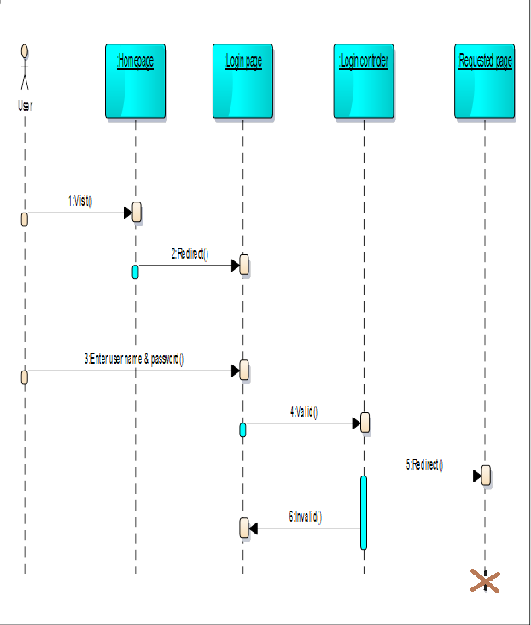

sequence diagram for login

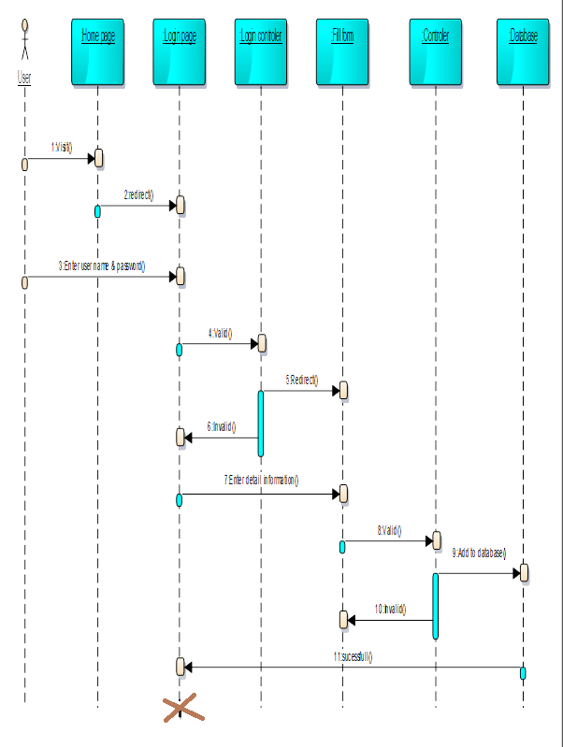

sequence diagram for fill form

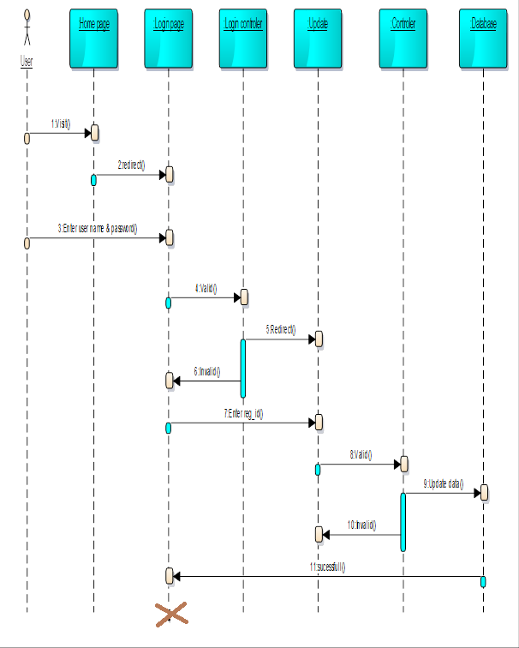

sequence diagram for update

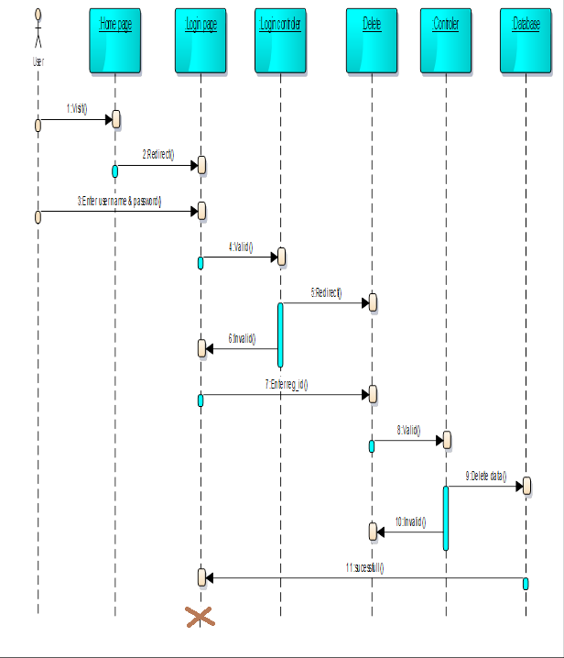

sequence diagram for delete

## Activity diagram

Activity diagrams are typically used for business process modeling, for modeling the logic captured by a single use caseor usage scenario, or for modeling the detailed logic of a business rule. Although UML activity diagrams could potentially model the internal logic of a complex operation it would be far better to simply rewrite the operation so that it is simple enough that you don't require an activity diagram. In many ways UML activity diagrams are the object-oriented equivalent of flow chart and data flow diagram (DFDs)  from structured development



activity diagram for login

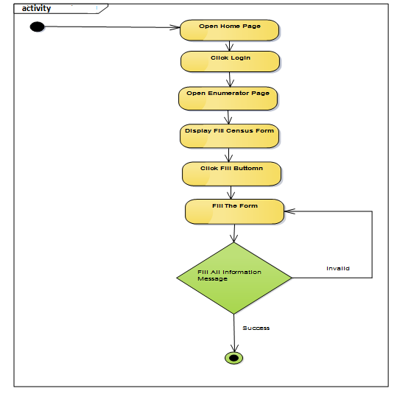

Activity Diagram for fill census form  
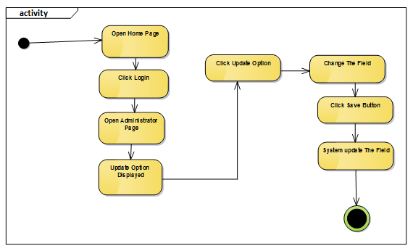

Activity Diagram for update census

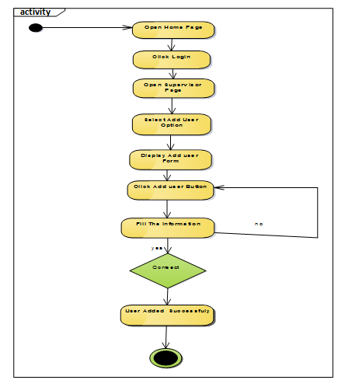

Activity diagram for register user

## State chart diagram

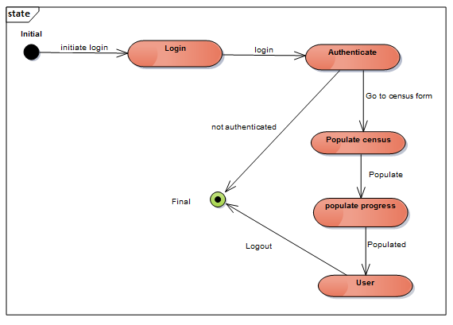

## User interface

User Interface (UI) Design focuses on anticipating what users might need to do and ensuring that the interface has elements that are easy to access, understand, and use to facilitate those actions. UI brings together concepts from interaction design, visual design, and information architecture.:

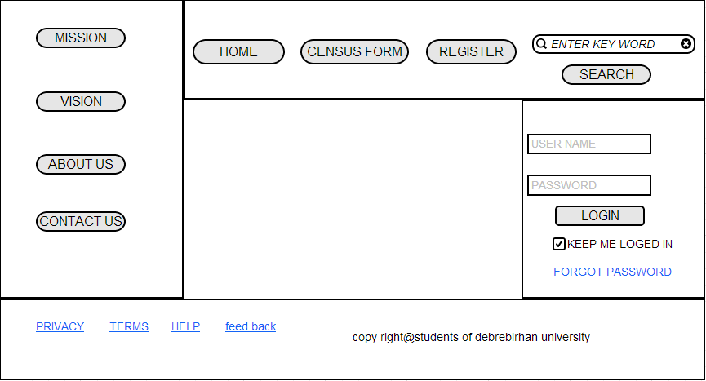

User interface for home page

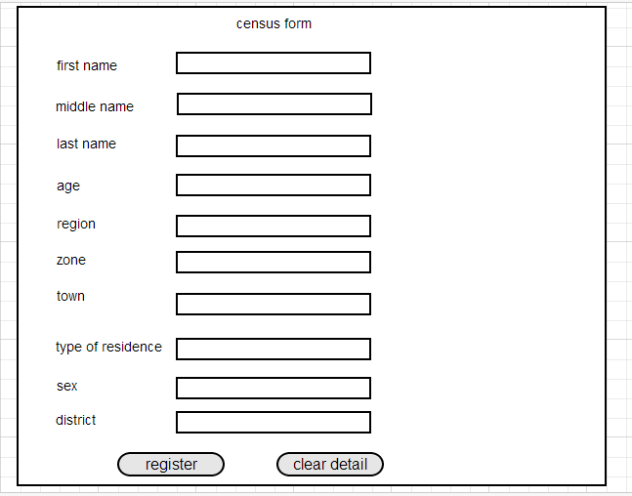

User interface for fill census form

# Chapter Four: System design

## Introduction

The purpose of designing is to show the direction how the system is built and to obtain clear and enough information needed to drive the actual implementation of the system. It is based on understanding of the model the software built on. System design is a phase of creativity rules where customer requirements, business needs and technical considerations all come together in the formulation of the system. Design is the first step to the development phase. The objectives of design are to model the system with high quality. Implementing of high quality system depends on the nature of design created by the designer. Generally this chapter describes how the project is designed, what tasks to done under the project and different modules and their way of functioning.

* 1. **Purpose of the system**

Software Design Specification Document contains design level statements regarding the system to be developed. This document is a detailed description of the system design for the online human population census system. i.e. the modules in the system and how they integrate and relate to each other. It is going to act as a guide for the system developer for it describes how system requirements contained in the requirement specification document are carried out or implemented in the system. The document would also show how users would visualize the system and detailed descriptions of the inputs, processes and anticipated outputs of specific sub-parts of the system. System Design Specification (SDS) is a description of how the anticipated functional and non-functional system requirements specified in the Software Requirements Specifications (SRS) are achieved in the system. This document generally includes the design of use case, sequence, activity diagrams.

* 1. **System architecture**

The system will replace the manual system in the organization by ensuring that all the users’ requirements are met. It will ensure that proper records are kept all backups are performed to prevent data loss, to develop a more customer focused service, to improve integrity impartiality and to improve accuracy of records kept.

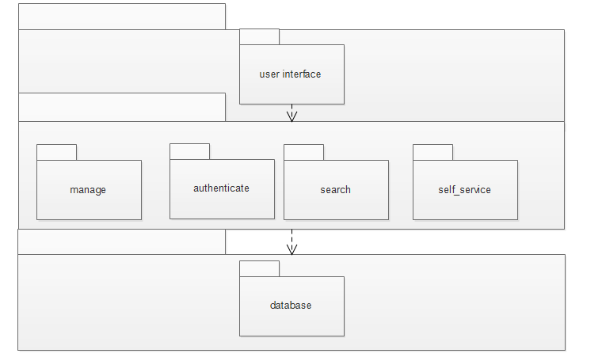

* 1. **Software/ hardware mapping**

In order to develop and implement the system there are software as well as hardware requirements. Deployment diagram show the physical view of our system. It is also used to show a collection of nodes and dependence of association among them. The physical deployment model provides a details model of the way component will be deployed across the system infrastructure. They present the distribution of the software components on the set of execution units. The UML diagram illustrates hardware/software mapping. In other words, deployment diagram show the hardware for our system, the software that is installed on hard ware used to connect the separate machine to one.

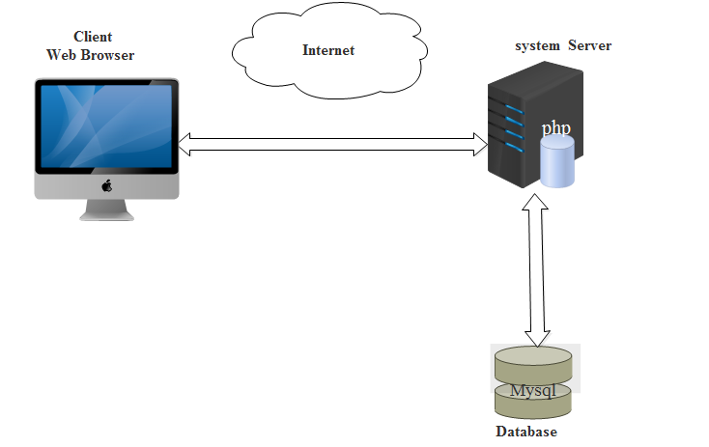

## Class modelling

## Analysis level Class Diagram (Conceptual Modelling)



## Component Diagram

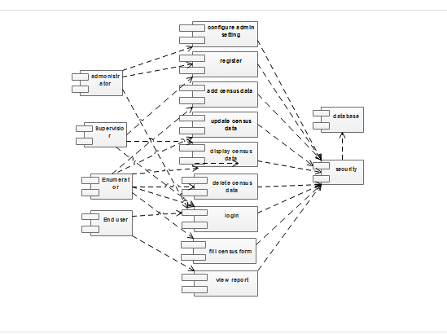

## Subsystem decomposition

The online census system is decomposed into subsystem. These subsystems are further decomposed into other subsystems. The major subsystems are:-person and housing unit enumeration, View enumerated census, Delete information and Update Information, View Census Report, Search, Feedback and User Account. Self-service subsystem: this subsystem mainly focuses on the services which enable the users to use the system. It includes services that related with update, search, select, request and delete. And shows the user how can view different reported item.

* ***Self-service subsystem***: this subsystem mainly concentrated on the services which enable the users to use the system. It includes services that related with select, update, delete and request. And shows the user how can view different census reported.
* ***Authentication subsystem***: it describes related services by giving and will be given authority in order to support access the system. Mainly focuses on how account and login are managed and administered. Includes manage user account ,login.
* ***Search subsystem***: it is mainly associated with searching required information. Also describes way of using different search key to finding required things. Includes search ,select.
* ***Manage subsystem***: this subsystem concentrated on manageable operation and how census rules are controlled, managed by whom. Includes manage census data, generate census report.

## Deployment Diagram

Deployment modelling is used to show the hardware of the system, the software that is installed in the hardware and also the middleware that is used to connect the disparate machines to one and other.



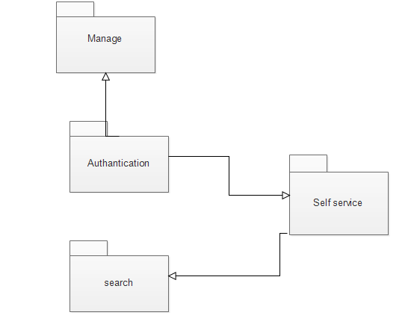

## Database design

## Entity relationship diagram

## Data Dictionary

This gives a brief description of the field names used in the tables and what they define as per the databases.

***Supervisor Table***

|  |  |  |  |
| --- | --- | --- | --- |
| Field name | Data type | Size | Description |
| supervisor_name | Varchar | 20 | Holds the name of the Supervisor |
| Supervisor_id | Number | 20 | Holds the First name of the Supervisor |
| first_name | Text | 20 | Holds other names of the Supervisor |
| last_name | Text | 20 | Field for identifier of the Supervisor |
| Address | Int | 10 | Holds the contact of the supervisor |
| email | Text | 20 | Highlights the email of the supervisor |
| Phone_no. | Int | 15 | Fields holds phone number of the supervisor |
| Password | Varchar | 20 | Indicates the password |

***Enumerator Table***

|  |  |  |  |
| --- | --- | --- | --- |
| Field name | Data type | Size | Description |
| Enumerator_name | Varchar | 20 | Holds the name of the Enumerator |
| Enumerator ID | Number | 20 | Holds the First name of the Enumerator |
| first_name | Text | 20 | Holds other names of the Enumerator |
| Last_name | Date time | 20 | Field for identifier of the Enumerator |
| Address | Date time | 10 | Holds the contact of the Enumerator |
| email | Text | 20 | Highlights the email of the Enumerator |
| Phone_no. | Int | 15 | Fields holds phone number of the Enumerator |
| Password | Varchar | 20 | Holds the name of the Enumerator |

***Household Table***

|  |  |  |  |
| --- | --- | --- | --- |
| Field Name | Data type | Size | **Description** |
| Location | Varchar | 20 | Indicates the location for household |
| Address | int | 20 | Indicates the Address for household |
| Place_of_birth | Varchar | 20 | Indicates the age of residents |
| Duration_of_residence | Varchar | 20 | Indicates the religion of residents |
| Religion | Varchar | 20 | Indicates the marital status of residents |
| Marital_status | Varchar | 10 | Indicates the birth place of residence |
| Orphan_hood | Varchar | 20 | Indicates the orphan in the residence |
| Previous_residence | Varchar | 20 | Indicates the previous residence of residents |
| Duration_of_residence | Int | 20 | Indicates the location for household |
| Nationality | Varchar | 20 | Indicates the tribe of residents |

## Modelling